Bug Tracking in Cloud Computing

Pavan Yendluri^{1*}
¹Depeartment of computer science, Lovely Professional University, Phagwara-144411, India.

*pavanyendluri588@gmail.com

Abstract— Bug tracking in cloud computing is critical to ensuring the stability and security of cloud services and applications. Cloud computing presents unique challenges for bug tracking, including complexity, scalability, lack of visibility, and security. To overcome these challenges, it is essential to adopt best practices such as continuous monitoring, a collaborative approach, root cause analysis, and automated testing. With these best practices in place, cloud computing environments can be more stable and secure, ensuring that applications and services run smoothly and without interruption. As cloud computing continues to evolve and becomes more prevalent, the importance of bug tracking will only increase. It is essential for organizations to prioritize bug tracking and invest in the tools and processes necessary to identify and resolve bugs in a timely manner. By doing so, they can ensure that their cloud services and applications remain stable and secure, providing value to their customers and driving business success.
.

Keywords-Bug tracking, Cloud computing, Quality assurance, Issue management, Agile methodology-y, Continuous integration continuous delivery (CI/CD).

- INTRODUCTION
In modern software development, cloud computing is a crucial element that provides businesses with convenient access to their applications and data through the internet. However, bugs and errors are inevitable in any software system, making a robust bug-tracking system necessary. Designed specifically for cloud-based software applications, a bug-tracking system helps developers manage and track bugs or defects, monitoring reported bugs, assigning them to relevant team members, and tracking progress until resolution.
Compared to traditional on-premises bug-tracking systems, cloud-based systems offer numerous benefits, such as easy accessibility from any location and scalability to handle large volumes of data and users. Additionally, they provide better data security since cloud providers monitor and manage their secure servers. However, cloud-based bug-tracking systems also face some challenges, including data privacy concerns and integration with other cloud-based software applications.
To overcome these challenges, cloud-based bug-tracking systems require certain features, such as strong data encryption and security measures, integration with other software applications, and robust reporting and analytics capabilities. These features enable developers to effectively track and resolve bugs in real-time, ensuring software applications run smoothly.
In conclusion, a bug-tracking system for cloud computing is essential for businesses using cloud-based software applications. While cloud-based bug-tracking systems offer several advantages, they also face challenges that need to be addressed. By incorporating the necessary features, cloud-based bug-tracking systems can effectively manage bugs, ensuring data privacy, integration with other software applications, and real-time monitoring and tracking of bug resolution.

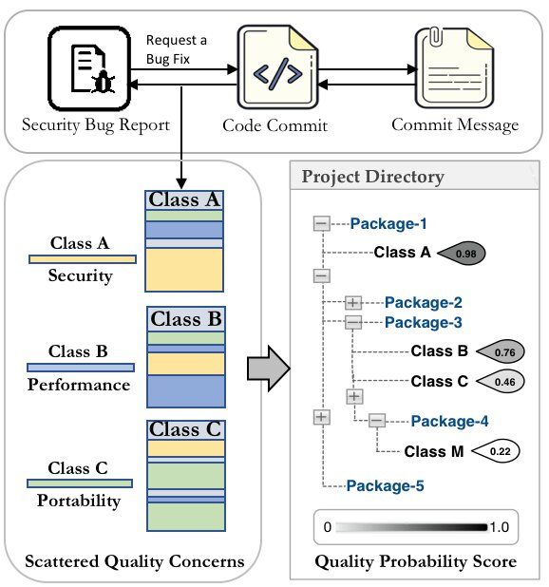
Figure 1. Bug report system working
[1] Software testing plays a critical role in identifying and detecting bugs, which often arise from errors and confusion in a program's source code or technical design. Detecting and managing bugs in software applications can be a challenge due to their various forms and complexities. To address this issue, bug-tracking systems have been developed to monitor and keep track of reported bugs in an application. Today, there are several proprietary and open-source bug-tracking systems available, and new systems are continuously being developed to cater to the changing software requirements that give rise to bugs. To address the need for a tool that can effectively fix and track the progress of bug fixes in the rapidly evolving software landscape, this paper presents a comparative study of five defect-tracking systems, including both open-source and proprietary options. Additionally, we propose a new defect tracking system called "Bugtrac," designed to address all types of software applications and the potential defects that may arise from them. We anticipate that this system will be a more promising defect-tracking solution compared to existing options.
[2]deploying multitenant applications on the cloud, achieving adequate isolation between tenants presents a significant challenge. To address this challenge, this paper explores the use of COMITRE, or Component-based approach to Multitenancy Isolation Through Request RE-routing, to evaluate the effectiveness of three multitenancy patterns: shared component, tenant-isolated component, and dedicated component. Specifically, we apply this approach to a cloud-hosted Bug tracking system that utilizes Bugzilla and empirically assesses the degree of isolation between tenants offered by each pattern.
Our study reveals that the use of dedicated components offers the highest degree of isolation, particularly in cases of database transactions where support for locking is enabled. On the other hand, for tenant isolation based on performance metrics like response time, the use of shared components appears to be more favourable compared to resource consumption metrics like CPU and memory, where the use of dedicated components is preferred. Finally, we discuss key challenges and recommendations for implementing multitenancy for application components in cloud-hosted bug-tracking systems, with an emphasis on ensuring isolation between multiple tenants.
[3] In software development, the main problem is recognizing the security-oriented issues within the reported bugs due to their unacceptable failure rate to provide satisfactory reliability on customer and software datasets. The misclassification of bug reports has a direct impact on the effectiveness of the bug prediction model.
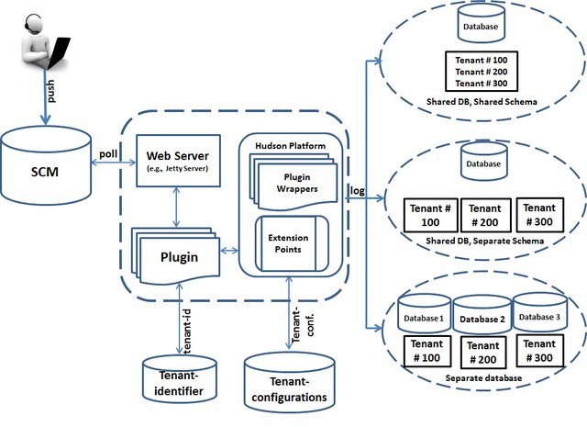
Figure 2. Multitenancy Data Isolation Architecture
The misclassification trouble in reality compromises the accuracy of the system. Manually reviewing bug reports is necessary to solve this problem, but doing so takes a lot of time and is tiresome for developers and testers. This paper proposes a novel hybrid approach based on natural language processing (NLP) and machine learning. To address these issues, the meant results are multi-elegance supervised class and malicious program prioritization of the usage of supervised classifiers. After being collected, the dataset becomes organized for vectorization, subjected to exploratory statistics analysis, and preprocessed. The function extraction and choice techniques used for a bag of phrases are TF-IDF and word2vec. Machine mastering fashions are created after the dataset has gone through a complete transformation. This study proposes, develops, and assesses four classifiers: multinomial Naive Bayes, decision trees, logistic regression, and random forest. The hyper-parameters of the fashions are tuned, and it's far concluded that random wooded area outperformed with a 91.73% take a look at and 100% schooling accuracy. The SMOTE approach turned into used to stabilize the tremendously imbalanced dataset, which turned into, to begin with created for the justified classification. The comparison between balanced and imbalanced dataset models clearly showed the importance of the balanced dataset in classification as it outperformed all experiments.

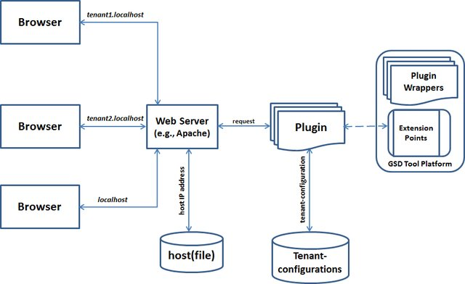
Figure 3. COMITRE Architecture
[4] In the context of open-source development projects, it is common to have an open bug repository where both developers and users can report bugs. However, triaging these reports can be a time-consuming task, particularly for large open-source projects that receive a high volume of bug reports. To address this issue, we propose a semi-automated approach that streamlines the assignment of bug reports to developers. Our approach involves using a machine learning algorithm to analyze the open bug repository and learn which types of reports each developer is most skilled at resolving. When a new bug report is submitted, the algorithm recommends a shortlist of suitable developers to assign the report to. Our method has done precision ranges of 57% and 64% at the Eclipse and Firefox improvement projects, respectively.. We have also applied our approach to the gcc open-source development project, although with less favorable outcomes. We discuss the conditions under which this approach is most effective and share the lessons we have learned about applying machine learning to repositories used in open-source development.
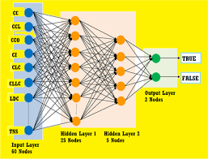
Figure 4. Neural Network used to bug tracking
[5] Bug repositories like Bugzilla and Jira are abundant with data from numerous projects, including various issue types such as bug reports, feature improvements, new product features, and tasks. Each issue type has multiple attributes, and manually collecting such vast amounts of data can be time-consuming, tedious, and error-prone. This paper focuses on reducing errors caused by human mistakes and improving accuracy by automating the collection of bug reports from Jira. The bug report collection system described in this paper is implemented in C# and utilizes REST APIs to extract data from the Jira repository. By making an HTTP request and parsing the response into objects, this tool automatically extracts information from over 100 Apache projects maintained by Jira and generates reports containing several bug attributes such as bug ID, one-line bug description, bug priority, bug components, bug long description, affected versions, assignee, and other attributes. Researchers can utilize these reports for further analysis, such as bug classification by type, bug prioritization, and prediction of bug severity using machine learning. Therefore, these generated reports are useful for researchers to analyze and prioritize bugs based on their assigned priorities and classify the frequency of different types of bugs in various projects, saving time and manual effort.
[6] During the era of big data and cloud computing, ensuring the reliability of distributed systems is of utmost importance. Regrettably, distributed concurrency bugs, commonly known as DCbugs, are prevalent and can be difficult to detect. These bugs reside within the vast state space of distributed cloud systems and manifest in a non-deterministic manner, depending on the timing of distributed computation and communication. To address this issue, this research paper proposes a novel solution, DCatch, for the detection of DCbugs. DCatch utilizes an analysis of the correct execution of distributed systems to predict and identify bugs. The conception of DCatch required devising a series of regulations that depict the occurrence sequence of events, encompassing various forms of communication and parallelism that are typically observed in distributed cloud systems found in actuality. Additionally, runtime tracing and trace analysis tools were designed to identify concurrent conflicting memory accesses in these systems, while tools to help eliminate false positives and trigger DCbugs were also developed. The effectiveness of DCatch was evaluated on four open-source distributed cloud systems, including Cassandra, Hadoop MapReduce, HBase, and ZooKeeper, by monitoring the correct execution of seven workloads on these systems. DCatch successfully identified 32 DCbugs, with 20 of them being genuinely harmful.
[7] When implementing multi-tenancy in a cloud-based software service, maintaining optimal performance and resource consumption for each tenant can be challenging. Designers and architects must ensure that the actions of one tenant do not negatively impact the experience of others. This research aims to identify the trade-offs, commonalities, and differences to be considered when implementing the necessary level of tenant isolation. Through an empirical cross-case analysis of multiple open-source software engineering tools hosted in the cloud, we assessed and measured varying levels of degrees.
of isolation between tenants. Our research uncovered five

common factors: disk space reduction, use of locking, low
Our research identified several factors that can impact tenant isolation, including cloud resource consumption, customization and use of plug-in architecture, and choice of multi-tenancy pattern. However, we found that customization and plug-in architecture can potentially compromise tenant isolation. On the other hand, we also discovered that careful management of workloads, implementation of data and process locking, and appropriate selection of multi-tenancy.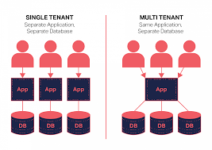
Figure 5. Single vs Multi-Tenant Cloud System

Our study also uncovered five differences across the case studies: data size, cloud resource consumption, sensitivity to workload changes, software process impact, and client latency and bandwidth. We concluded that large data sizes, high resource consumption by specific processes, fluctuating workloads, low client latency, and bandwidth when transferring multiple files can all have a negative impact on isolation. Additionally, we developed a framework that explains how tenant isolation can be mapped to different software development processes, cloud resources, and layers of the cloud stack. This framework also highlights the trade-offs involved in achieving tenant isolation, such as resource sharing, number of users/requests, customizability, data size, control over the cloud application stack, and business constraints. Our research suggests that software architects must consider the trade-offs, commonalities, and differences identified in our study to effectively meet their tenant isolation requirements.
[8] Deploying a multi-tenant architecture in a cloud-based software service can pose challenges in maintaining optimal performance and resource consumption for each individual tenant. To ensure a positive experience for all tenants, designers and architects must prevent the actions of one tenant from adversely affecting others. The primary aim of our research is to identify and analyze the trade-offs, similarities, and differences that must be taken into account when implementing an appropriate level of tenant isolation in a multi-tenant cloud-based software service.. Using a cross-case analysis of various open-source cloud-hosted software engineering tools, we empirically evaluated different degrees of isolation between tenants. In our study, we identified five factors that can contribute to enhancing tenant isolation: reducing disk space, implementing locking, minimizing cloud resource consumption, utilizing customization and plug-in architecture, and selecting an appropriate multi-tenancy pattern. However, we also found that customization and plug-in architecture, while beneficial, can potentially compromise tenant isolation.
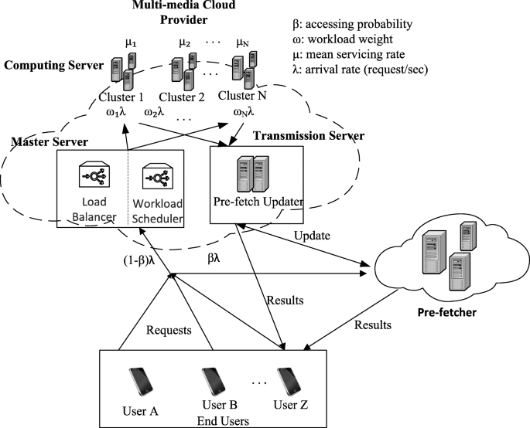
Figure 6. Data transmission among cloud and give up customers withinside the presence of pre-fetcher
In careful attention is given to managing workloads, implementing data and process locking, and selecting appropriate multi-tenancy patterns, it is possible to enhance isolation. However, our analysis revealed five distinct differences across the case studies: data size, cloud resource consumption, sensitivity to workload changes, software process impact, and client latency and bandwidth. Our findings indicate that large data sizes, high resource consumption by specific processes, fluctuating workloads, low client latency, and bandwidth when moving multiple files can all hinder isolation. Additionally, we developed a framework that explains how tenant isolation can be mapped to software development processes, cloud resources, and layers of the cloud stack. This framework also highlights the trade-offs involved in achieving tenant isolation, such as resource sharing, number of users/requests, customizability, data size, control over the cloud software stack, and business constraints. Our research suggests that software architects must consider these trade-offs, as well as the commonalities and differences identified in our study, to effectively meet their tenant isolation requirements.
[9] The demand for a comprehensive understanding of fault analysis and recovery mechanisms in service-oriented systems (SOSs) is growing due to their increasing scale and complexity. To meet this need, a systematic literature review (SLR) was conducted to provide a summary of the current state-of-the-art in SOSs fault analysis. The SLR followed a predefined method and included a manual search of 11 highly reputable international journals and three conference proceedings. The papers were categorized and organized based on research questions pertaining to fault analysis approaches, types of faults, current issues and challenges, and tools. The ensuing overview consists of 123 papers posted among January 2008 and April 2017, with sixty five addressing fault handling Approaches, 35 reporting SOS-particular faults, fifty one addressing issues, challenges, and trying out of SOSs, and 17 associated with tooling. The review discusses the main approaches, techniques, concepts, contributions, and research methods used for fault analysis in SOSs. Overall, this comprehensive review provides empirical evidence that can inform future research agendas in this field.

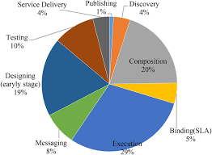
Figure 7. Fault analysis of service-oriented systems
[10] In a cloud-hosted application, tenants often share components and resources to reduce costs and resource consumption. However, this can lead to performance issues and access problems if one tenant experiences a sudden increase in workload and the application does not scale up accordingly.This problem can be exacerbated when certain components have varying degrees of isolation. To address this, this paper proposes a decision-based model that consists of an optimization model, an open multiclass queuing network model, and a metaheuristic algorithm to determine the optimal deployment of components for a cloud-hosted application that ensures the required degree of multitenancy isolation. The model was tested through experiments, which showed that the optimal solutions obtained from the model had low variability and deviation when compared to actual optimal solutions. The paper also discusses the potential applications of the optimization model and highlights the challenges and recommendations for deploying components with varying degrees of isolation.
[11] Cloud-hosted application tenants seek to decrease costs and reduce resource consumption by sharing components and resources. However, resource sharing can impact access and performance for tenants if one experiences a sudden increase in workload, especially if the application does not handle the workload. This issue can be severe when there is a higher or varying degree of isolation between components. The aim of this paper is to introduce new solutions for deploying components of a cloud-hosted application to ensure the necessary level of multitenancy isolation through a mathematical optimization model and metaheuristic algorithm. The research presented in this paper shows that the model's optimal solutions exhibit low levels of variability and only a small percentage deviation. Additionally, this paper explores the possible areas of application of our optimization model, as well as the challenges and recommendations for deploying components with varying degrees of isolation.
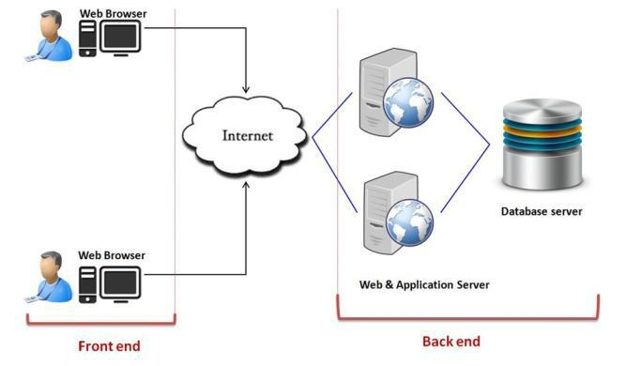
Figure 8. Real life cloud environment
[12] Multitenancy is the capability that allows multiple tenants to access a single instance of a cloud offering. However, there has been a lack of focus on implementing the necessary degree of isolation, which can differ among tenants, despite the variety of approaches available for implementing multitenancy. This paper proposes a framework for achieving the necessary level of isolation between tenants accessing a cloud service, which guarantees optimal performance, resource utilization, and overall efficiency and access privileges of one tenant do not impact other tenants during workload fluctuations. The framework consists of two key components: 1) the component-based approach to multitenancy isolation via request re-routing (COMITRE); and 2) an optimization model that generates optimal solutions for deploying components of a cloud-hosted service. We showcase the effectiveness of the framework by employing it in a case study of a cloud-hosted bug-tracking system and a synthetic dataset, attaining the necessary level of isolation and optimal deployment solutions.
[13] Cloud-hosted applications often share components and resources among tenants to reduce costs and resource consumption. However, this sharing can lead to issues where the behaviour of one component impacts the performance, resource usage, and access privileges of others, especially if the application fails to scale up during sudden workload spikes. These issues are exacerbated when components have different or varying degrees of isolation. This paper proposes a mathematical optimization model and a simulated annealing-based metaheuristic solution to deploy components of a cloud-hosted application while ensuring the necessary degree of isolation between them. Our experiments demonstrate that the near-optimal solutions obtained from our model had low variability and percent deviation compared to the optimal solution. Additionally, we provide recommendations for deploying components with varying degrees of isolation.
[14] Software engineering research areas like mutation testing, automatic repair, fault localization, and fault injection rely on empirical knowledge of frequently occurring bug-fixing code changes. Previous studies in this field have focused on what changes have been made due to bug-fixes in terms of code edit actions but have overlooked the context of the change. Knowing about the context of bug-fix changes can potentially narrow down the search space for many software engineering techniques by focusing on specific parts of the software. Moreover, maximum preceding studies has targeted on C and Java projects, leaving an opening in empirical proof approximately bug-solving modifications in Python software.. This paper addresses these gaps by conducting an extensive empirical analysis of bug-fixing changes in three OpenStack projects, considering both the what and the where of the changes. The findings indicate that recreating change patterns aren't unconscious to the girding law but tend to do in specific law surrounds.
[15] This paper addresses the challenge of detecting quality bugs, which are often difficult to identify due to the scattered nature of quality-related features across the codebase. To overcome this limitation, the authors propose a solution that leverages a Hierarchical Dirichlet Process (HDP) topic modeling technique in conjunction with structural and textual analyses to capture the hierarchical topical relationships among quality features. Their solution, called SOFTQUALTOPICDETECTOR, clusters scattered quality concerns into a meaningful hierarchy to infer a set of candidate classes that are relevant for recommending the repair of quality bugs. The authors also incorporate three visual features to monitor, prioritize, and trace suspicious classes for improving maintainability, functional suitability, and traceability.The empirical evaluation of the SOFTQUALTOPICDETECTOR indicates a considerable improvement over both the baseline and state-of-the-art methods, particularly in terms of average precision and recall.
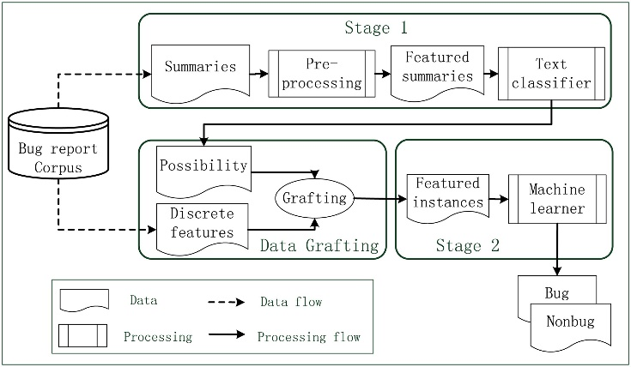
Figure 9.The Combining text mining and data mining for bug report classification
[16] The paper presents a novel mining approach for identifying fix patterns in Python programs by extracting fine-grained code changes made during the process of bug fixing. The approach employs the repetitiveness of code changes to generate bug fix patterns, which can be used as a critical component of Automatic Program Repair (APR) to automatically detect and fix bugs in software products. The paper collects bug reports from GitHub and clusters similar bug-fixing code changes using abstract syntax tree edit distance to generate fix patterns. The effectiveness of these fix patterns is estimated by applying them to single- hunk bugs in two marks, BugsInPy and QuixBugs. The results show that 13 out of 101 real bugs can be fixed without human intervention, and for each complex bug, 15% of the bug code could be fixed, The paper also highlights the limitations of using fix patterns proposed for other programming languages in Python programs due to syntactic incompatibilities and lack of analysis of dynamic features. The proposed approach addresses these limitations and demonstrates the potential of using fix patterns to improve the quality of Python programs.
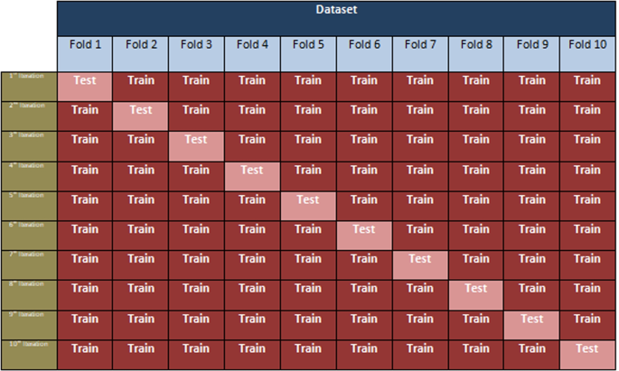
Figure 10. Bug tracking software using deep learning.
[17] The paper describes the development of a tool called Python Change Miner that can discover code change patterns in the histories of Python projects. The tool was validated and used to identify patterns in a dataset of 120 projects from four different domains of software engineering. The authors manually categorized the patterns that occur in more than one project and compared different domains and patterns in terms of their structure and content. They conducted a survey of the authors of the discovered changes and found that most of them could give the change a name and expressed their desire to have the changes automated. The authors of the study also conducted interviews with members of a development team responsible for a widely used integrated development environment (IDE) to assess the feasibility of implementing the identified changes through automation. The study found that independence from context and high precision made a pattern a better candidate for automation, and several patterns were ranked as very likely for automation. Overall, the study suggests that discovering code change patterns can provide insights into the nature of software development and lead to practical solutions for developers.
[18] ProFIPy is a new fault injection tool for Python software that enables users to specify their own software fault model using a domain-specific language (DSL) for fault injection. The tool is designed to be programmable, allowing users to customize the fault injection process to their specific needs. Additionally, ProFIPy is provided as software-as-a-service, making it more user-friendly and easier to access. The tool supports users through the configuration of the fault load and workload, analysis of failure data, and full automation of experiments using container-based virtualization and parallelization. With these features, ProFIPy can help developers and software engineers test the resilience and robustness of their software, and identify and fix potential faults before they cause significant problems or downtime.
[19] Deep Learning (DL) frameworks have become essential tools for developers to create DNN models without having to learn the underlying algorithms and models. These frameworks have been deployed in safety-critical areas like self-driving cars and medical diagnostics, making it crucial to identify and characterize bugs that could potentially impact their reliability. The objective of our research is to classify common DL framework bugs at the source code level, analyze their symptoms, root causes, and solutions, and provide insights to researchers to develop quality assurance techniques such as automatic repair and fault location techniques.
To achieve this objective, we began by summarizing the reference architecture of DL frameworks and proposed a DL framework bug taxonomy. We then analyzed 1,127 bug reports from eight popular DL frameworks and categorized the bug types, root causes, and symptoms. Our research findings show that DNN model building bugs and general type bugs account for one-third of the total defects DNN (Deep Neural Network) model building bugs are commonly associated with algorithm logic constraints, internal API errors, and data/numerical errors. Additionally, we identified fifteen bug-fixing patterns that can be used as a reference for DL framework bug repair and future research on automatic DL framework bug detection tools.

Our analysis of bug-fixing changes has provided valuable insights into the occurrence, root causes, symptoms, and fixing of these bugs. This study can help researchers ensure DL framework quality and provide actionable recommendations for DL framework developers to enhance the quality of their code.
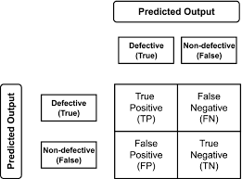
Figure 11. Prediction matrix of the deep learning mode.
[20] The rapid pace of evolution in cloud computing software is creating a dilemma for our increasing reliance on cloud computing. While cloud software must be agile to remain competitive, critical services are becoming increasingly dependent on the cloud and require high availability through strict Service Level Agreements (SLAs) for cloud infrastructures. This constant push to increase the frequency of cloud upgrades while maintaining service availability is unsustainable. In this paper, we discuss the challenges and opportunities for cloud upgrades. In our study, we analyzed the release histories of multiple cloud applications to investigate their rate of evolution and evaluate the existing limitations of cloud upgrade mechanisms. We identified several potential solutions for sustaining this evolution and improving availability, with a particular focus on the distinctive features of cloud computing. By outlining these promising avenues for achieving our objectives, we proposed a research agenda for future software upgrades in the cloud.
SUMMURY
Effective bug tracking is a crucial aspect of software development, and it becomes even more vital in cloud computing due to its distributed nature. Although cloud computing offers various benefits, including scalability, elasticity, and cost-effectiveness, the rapid evolution pace of cloud software is in conflict with the growing reliance on cloud computing, making it imperative to improve bug tracking in cloud computing.
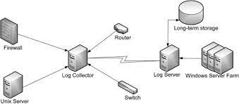
Figure 12. Bug Tracking System
The objective of this research is to investigate the challenges and opportunities for bug tracking in cloud computing. The study underlines the importance of efficient bug tracking in cloud computing as the number of critical services dependents on the cloud continues to increase. Additionally, it is essential to ensure high availability through firm Service Level Agreements (SLAs) for cloud infrastructures.
This research explores the shortcomings of current bug tracking mechanisms in cloud computing and proposes solutions to overcome these challenges. The study analyzes the release histories of several cloud applications to determine their evolution pace, and it identifies the challenges of cloud upgrade mechanisms. The proposed solutions to improve bug tracking efficiency in cloud computing include automated bug tracking, better collaboration between developers and users, and improved integration of bug tracking systems with cloud infrastructure. The research suggests that these solutions can help sustain the evolution pace of cloud software while enhancing availability.

Finally, the study suggests a research agenda for the future of bug tracking in cloud computing. It emphasizes the importance of more research in areas such as automated bug detection, root cause analysis, and machine learning-based approaches to bug tracking. The research also underscores the need for collaboration between researchers, developers, and users to ensure effective bug tracking in cloud computing.

REFERENCES
- Gopal, M. K., Govindaraj, M., Chandra, P., Shetty, P., & Raj, S. 2022, February). Bugtrac–a new improved bug tracking system. In 2022 IEEE Delhi Section Conference (DELCON) (pp. 1-7). IEEE.
- Ochei, L. C., Petrovski, A., & Bass, J. M. (2016, June). Implementing the required degree of multitenancy isolation: A case study of cloud-hosted bug tracking system. In 2016 IEEE International Conference on Services Computing (SCC) (pp. 379-386). IEEE.
- Tabassum, N., Namoun, A., Alyas, T., Tufail, A., Taqi, M., & Kim, K. H. (2023). Classification of Bugs in Cloud Computing Applications Using Machine Learning Techniques. Applied Sciences, 13(5), 2880.
- Anvik, J., Hiew, L., & Murphy, G. C. (2006, May). Who should fix this bug?. In Proceedings of the 28th international conference on Software engineering (pp. 361-370).
- Kaur, A., & Jindal, S. G. (2017, January). Bug report collection system (BRCS). In 2017 7th International Conference on Cloud Computing, Data Science & Engineering-Confluence (pp. 697-701). IEEE.
- Liu, H., Li, G., Lukman, J. F., Li, J., Lu, S., Gunawi, H. S., & Tian, C. (2017). Dcatch: Automatically detecting distributed concurrency bugs in cloud systems. ACM SIGARCH Computer Architecture News, 45(1), 677-691.
- M. Grottke, R. Matias Jr., and K. S. Trivedi, The fundamentals of software aging, In Proc. of the 1st Int'l Workshop on Software Aging and Rejuvenation (WoSAR2008), pp.1-6, 2008.
- Ochei, L. C., Bass, J. M., & Petrovski, A. (2018). Degrees of tenant isolation for cloud-hosted software services: a cross-case analysis. Journal of Cloud Computing, 7(1), 1-39.
- Bhandari, G. P., & Gupta, R. (2018). Fault analysis of service‐oriented systems: a systematic literature review. IET Software, 12(6), 446-460.
- Ochei, L., & Petrovski, A. (2018). A Decision-based Model for Optimizing the Deployment of Cloud-hosted Application Components to Guarantee Multitenancy Isolation.
- Ochei, L. C., & Ejiofor, C. I. (2018). A model for optimising the deployment of cloud-hosted application components for guaranteeing multitenancy isolation. Advances in Science, Technology and Engineering Systems Journal, 3(2).
- Ochei, L. C., Petrovski, A., & Bass, J. M. (2018). A framework for achieving the required degree of multitenancy isolation for deploying components of a cloud-hosted service. International Journal of Cloud Computing, 7(3-4), 248-281.
- Ochei, L. C., Petrovski, A., & Bass, J. M. (2016, October). Optimizing the deployment of cloud-hosted application components for guaranteeing multitenancy isolation. In 2016 International Conference on Information Society (i-Society) (pp. 77-83). IEEE.
- Cotroneo, D., De Simone, L., Iannillo, A. K., Natella, R., Rosiello, S., & Bidokhti, N. (2019, October). Analyzing the context of bug-fixing changes in the openstack cloud computing platform. In 2019 IEEE 30th International Symposium on Software Reliability Engineering (ISSRE) (pp. 334-345). IEEE.
- Krasniqi, R., & Do, H. A Hierarchical Topical Modeling Approach for Recommending Repair of Quality Bugs.
- Yang, Y., He, T., Feng, Y., Liu, S., & Xu, B. (2022). Mining Python fix patterns via analyzing fine-grained source code changes. Empirical Software Engineering, 27(2), 48.
- Golubev, Y., Li, J., Bushev, V., Bryksin, T., & Ahmed, I. (2021). Changes from the trenches: Should we automate them?. arXiv preprint arXiv:2105.10157.
- Cotroneo, D., De Simone, L., Liguori, P., & Natella, R. (2020, June). Profipy: Programmable software fault injection as-a-service. In 2020 50th annual IEEE/IFIP international conference on dependable systems and networks (DSN) (pp. 364-372). IEEE.
- Yang, Y., He, T., Xia, Z., & Feng, Y. (2022). A comprehensive empirical study on bug characteristics of deep learning frameworks. Information and Software Technology, 151, 107004.
- Neamtiu, I., & Dumitraş, T. (2011, September). Cloud software upgrades: Challenges and opportunities. In 2011 International Workshop on the Maintenance and Evolution of Service-Oriented and Cloud-Based Systems (pp. 1-10). IEEE.

